In the dynamic landscape of software development, the Scrum-Agile framework has emerged as a powerful methodology for enhancing team collaboration and project success. This paper acts as a Sprint Review and Retrospective exercise and adopts the perspective of a Scrum Master. Through the lens of our course project, the SNHU Travel initiative, this analysis will explore how the diverse roles within a Scrum-Agile team contributed to achieving project goals, the completion of user stories through structured methodologies, and the team's resilience in the face of interruptions. Furthermore, it will delve into the efficacy of communication strategies that fostered collaboration, evaluate the organizational tools that supported workflow, and assess the overall effectiveness of the Scrum-Agile approach. By examining both the advantages and disadvantages encountered during the project, this paper aims to provide a comprehensive evaluation of whether Scrum-Agile was the most suitable methodology for this project.

ROLES
The whole is greater than the sum of its parts- Aristotle

Each role within our Scrum-Agile Team was vital to the holistic success of this project. Below is a table that combine’s the Project Team information from our project charter with a highlighted impact from each role that was essential for the success of the SNHU Travel Project.
ROLE | TEAM MEMBER | INDISPENSABLE IMPACT
Scrum Master | Ron | Facilitated collaboration and communication while upholding the Scrum framework effectively to meet project goals.
Product Owner | Christy | Primary liaison between stakeholders and the agile team; ensured the product vision was well defined, prioritized, and effectively executed on for maximum user value.
Developer | Nicole | The craftsperson who transformed the product’s vision, backlog and user stories into tangible, high-quality software, offering continuous increments of value.
Tester | Brian | Ensured the quality and reliability of the product to meet user needs by providing timely feedback, testing exercises, and bug identification/fixes.
Client | Amanda | Essential for provision of information and context, alongside timely client-side feedback and approvals.

A prime illustration of how each role is critical to project success was found in Week 5 when an important change pivoted the product from its initial vision highlighting top travel destinations to centering on the wellness travel industry. The client was essential in promptly communicating the new information. The Scrum Master was essential in facilitating the agile framework through this change. The Product Owner was essential in transcribing this change into Product Backlog and User Story edits. The Tester was essential in adjusting the test cases in reaction to this change. Finally, the developer was essential in executing the new changes and reflecting this in the software.

USER STORIES
Stories are the shortest distance between two people- Patti Digh

User stories effectively capture and communicate product requirements in a clear and user-centric manner. This approach fosters collaboration and ensures the product is built with a focus on the delivery of real value to the user, while also promoting the iterative development process.
The Scrum-Agile approach to the SDLC enables the execution of user stories by providing an accessible framework for how work is identified, prioritized, and completed. User stories are transcribed into tasks and prioritized in the Product Backlog. These tasks are then selected during Sprint Planning to accomplish the relevant sprint goal. Daily stand-ups provide cross-team transparency on the status of these tasks and any blockers requiring support. Once produced, the work borne out of those initial user stories is tested to ensure the output meets acceptance criteria. Testing feedback funnels back into the agile system, informing on future iterations until a quality product that honors the user stories is live.
At the start of this course, I found visual infographics, like the one below, invaluable in helping me grasp how Agile terminology and concepts function as a cohesive system.
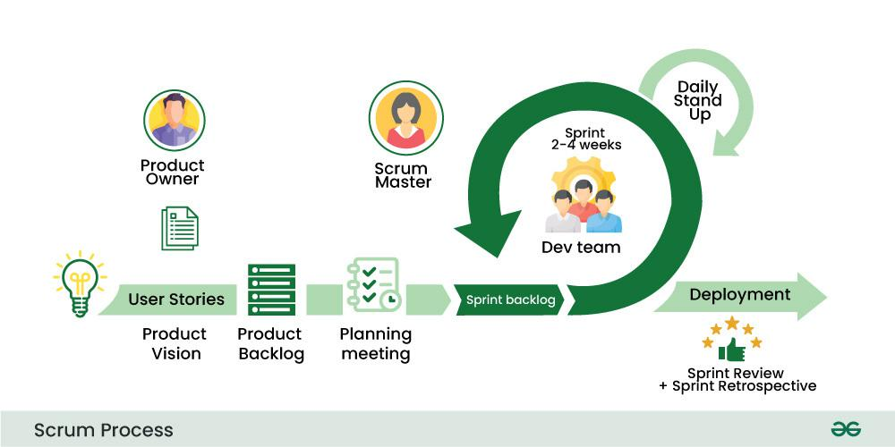
(GeeksforGeeks, 2023)
As I took on different roles within the Agile team, I had the chance to experience these components in practice. For example, when working as the Tester, the task of identifying test cases showed how the Agile methodology brings User Stories to life. These test cases provided detailed, step-by-step actions and expected outcomes to validate the acceptance criteria within the User Story. This part of the Agile-Scrum process transformed abstract requirements into concrete, measurable actions to validate success of that work. Below I’ve included a side-by-side sample of a User Story that was transcribed into a Test Case.
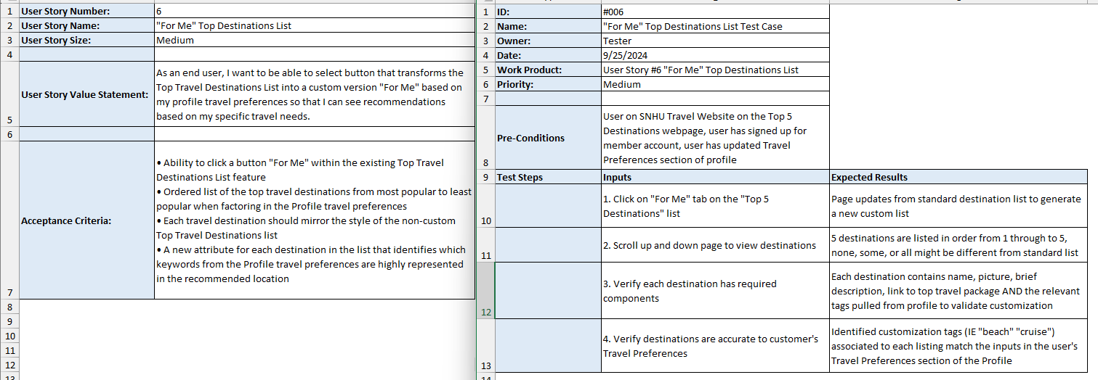

HANDLING INTERRUPTIONS
The only constant in life is change- Heraclitus

Agile methodology is fundamentally designed to accept interruptions. A project designed within the waterfall methodology may face significant trouble should a notable pivot arise halfway through the project, long after planning has solidified an inflexible pathway. However, agile principles both embrace and encourage flexibility, adaptability, and responsiveness to change.
During this SNHU Travel project, the agile framework equipped the team to navigate changes while supporting project completion. For example, when a change on the design and development side altered the Top 5 Destinations feature from a list-design to a slideshow-design, test cases were revised to ensure that the relevant new functionality was accurately tested. This demonstrates the receptiveness of the agile framework to an organized domino effect of responding to changes. Also, when the client wanted to center wellness travel on their website, there was no frantic scramble. The framework provides acceptance of this change via our ability to revise or add User Stories, change the Product Backlog, update Test Cases, and to plan the next Sprint to be responsive to the new priority without major disruption to the overall project and the original timeline constraints. Because work is broken into increments, a change like this was able to be actioned promptly within the next sprint. Should any team member have come across a blocker or challenge following this change, the Daily Standup provided an opportunity to promptly flag this for collaborative problem solving. Each team member acts with self-sufficiency and is therefore prepared to act on the expectation that they communicate their needs, pivot their actions, and accomplish their portion of responding to this change.
COMMUNICATION
The single biggest problem in communication is the illusion that it has taken place- George Bernard Shaw

Communication and transparency are vital components of successful Agile-Scrum methodology. Fortunately, it provides some important structured communication practices including scrum events: Daily Scrum / Standup, Sprint Planning, Sprint Review, Product Backlog Review, as well as asynchronous communication tools: information radiators, user stories, tester documentation, and use of organization tools or software.
The SNHU Travel Project accentuated the need for strong communication several times. Below are two examples of emails that demonstrate how to clearly communicate a need to a specific target, who can then understand their direct action. The first is the team Tester requesting information from the Product Owner on how a design change impacts their revision of test cases to ensure accuracy. The second is from the team Developer reaching out to both the Product Owner and Tester to illuminate how their three roles have interrelated dependencies that must be navigated to ensure effective responsiveness to a client change request. When it comes to email correspondence on an agile team, some best practices include:
- CC’ing all relevant parties, but excluding unnecessary parties
- Providing concise context, specific asks, and concrete actions
- Stating the required response time or due date
- Using intuitive formatting
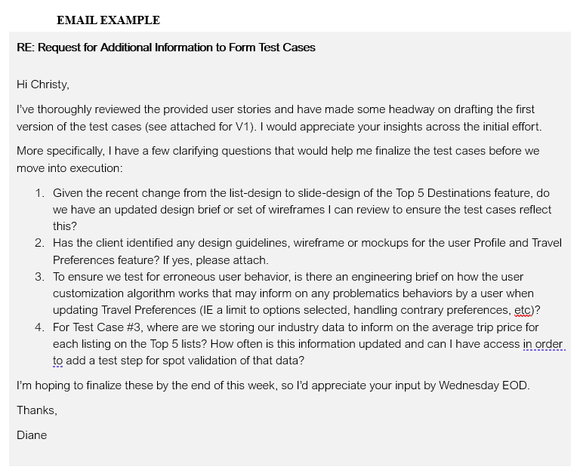
In addition to these emails, looking back at the resources around Scrum Events alongside the Project Charter, User Stories, and Test Case assignments, all were communication efforts that foster alignment and clarity across the team’s roles and project’s scope. Finally, Module 6 provided the opportunity to practice communication asynchronously with our peers: from self-organizing to determine our chosen role, to collaborating on each other’s posts for the best version of what was initially drafted. Though one’s tasks may have them working in a specialist, silo-like capacity, the infrastructure within the agile framework facilitates information sharing and collaborative communication far beyond that silo.
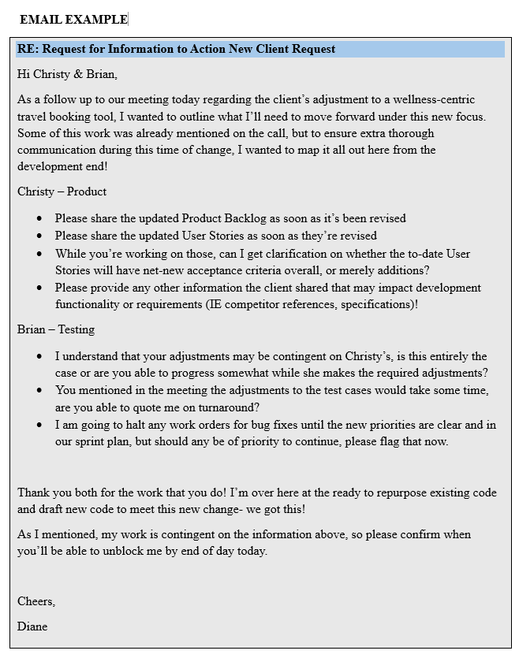

ORGANIZATIONAL TOOLS
For every minute spent organizing, an hour is earned- Benjamin Franklin

Throughout this course and the example SNHU Travel project, several organizational tools were either directly practiced, or detailed via resources, to support the successful execution of Scrum-Agile methodology. [NOTE: some information below is written to detail some imagined scenarios in order to best communicate takeaways for this topic]
Scrum Events played a crucial role in maintaining communication and fostering collaboration among team members. Product Backlog Reviews enabled the Product Owner to continuously refine, prioritize, and estimate User Stories in response to customer feedback, stakeholder input, or contextual information. During Sprint Planning, we collectively determined the scope of work for the upcoming sprint, ensuring alignment with our goals and the Product Owner’s vision. Daily Stand-ups served as a cornerstone of our communication strategy, allowing team members to share updates on their progress, identify obstacles, and adjust plans as needed. These brief meetings not only promoted transparency and accountability, but also nurtured a culture of openness, where team members felt comfortable discussing challenges and seeking assistance. Finally, Sprint Reviews provided an invaluable platform to demonstrate completed work to stakeholders and gather feedback to inform on future efforts.
Our team used an Information Radiator as an additional organizational tool. A giant whiteboard was placed in a communal area to enable team members to plainly see key priorities and updates both within and across roles. This board functioned as a high-level central-source-of-truth to promote transparency and accountability.
To round out the use of scrum events and provide depth to the information radiator, our team leveraged a project management software built specifically for agile projects: Jira. This tool was used across all team members, provided easy access to updates and issues, enabled the effective management of the Product Backlog and progress of User Stories, and tracked tasks, statuses, and deadlines to a granular level. It was important that we integrated the use of Jira with running Scrum Events. Each event mentioned previously was executed with support of the Jira software. For example: during Product Backlog reviews, the digital backlog in Jira was updated in real-time; during Daily Standups, Jira’s kanban board (updated in advance) provided the team with a visual aid of that sprint’s tasks and statuses. Project management tools like Jira allow for a good deal of customization, so our team was able to fine-tune our use of the tool and its support of strong agile-scrum practices during Sprint Retrospectives.

EVALUATING AGILE
We do not learn from experience, we learn from reflecting on experience- John Dewey

Overall, the use of agile methodology for the SNHU Travel project was an excellent learning opportunity and general success. I’ve detailed some experienced or imagined pros and cons in reflection of this coursework.
PROs | CONs
- Provided flexibility and adaptability for the change that occurred through the project  - Enabled the ability for frequent feedback to be received and actioned  - Incremental delivery of work was able to be shown to stakeholders  - The focus on user stories positions the final product to perform well in a competitive market  - Continuous testing led to a higher quality product with fewer bugs at launch  - Risk was lessened with this approach, allowing for more innovation and experimentation  - Collaboration across the team solidified alignment and minimized miscommunications | - Frequent meetings take up notable time and resources  - Inexperienced team members of agile had some struggles with effective participation  - Scope creep had to be mitigated almost weekly due to continuous new ideas  - Some concerns of integrating this new feature into SNHU’s broader web properties

Despite the identification of these cons, the pros outline why agile methodology is the preferred approach to a project like the SNHU Travel project. Agile proves to reign supreme when it comes to navigating software development life cycle projects. Software development is a competitive and rapidly shifting discipline, regardless of the industry it’s built for, and leveraging a methodology that was designed to directly embrace change via iterative and nimble practices ensures that projects like the SNHU Travel project stand the best change at success in creating high-quality products. Ultimately, Agile stands out as the preferred approach in the software development field, driving innovation and customer satisfaction in an increasingly dynamic market.

REFERENCES
GeeksforGeeks. (2023). Scrum development model in SDLC. Retrieved October 2, 2024, from https://www.geeksforgeeks.org/scrum-development-model-in-sdlc/

